# **ATLANTIC KITCHEN POS**

# **User Manual**

## TYPE OF USERS

1. **Administrator / Manager** – the one who has the authorization in using the system and is in charge of modifying user accounts, item information, discounts and charges, viewing order transactions and reports.
2. **Cashier** – the one who has the authorization in using the system and is in charge of taking customer’s order, viewing customer’s order transactions information and updating the stocks of items in inventory.

## **For Administrator / Manager**

### **Login**

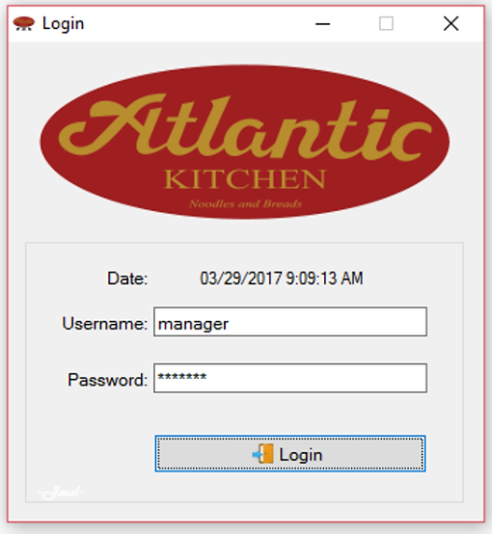

**To Login:**

1. Input **username** and **password**.
2. Then, click **Login** button. The main form will appear.

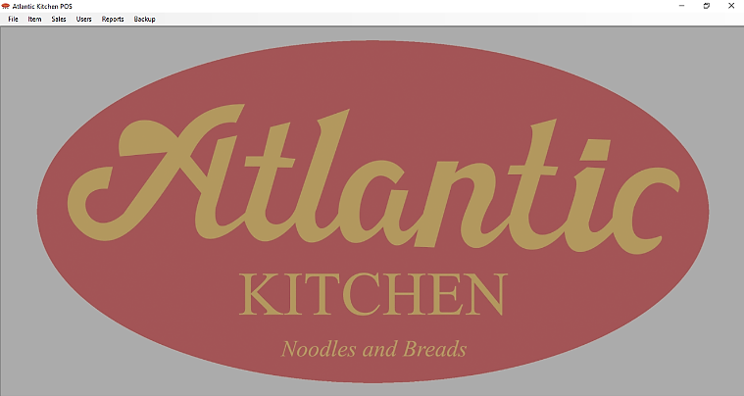

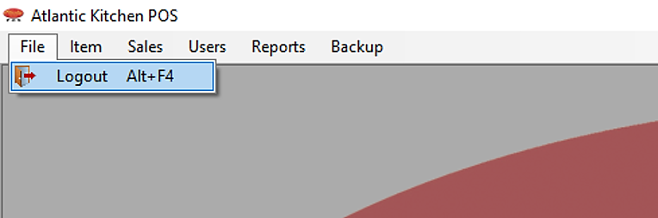

**To Logout**

1. Click the **File** menu.
2. Then, click **Logout** or press **Alt + F4.**

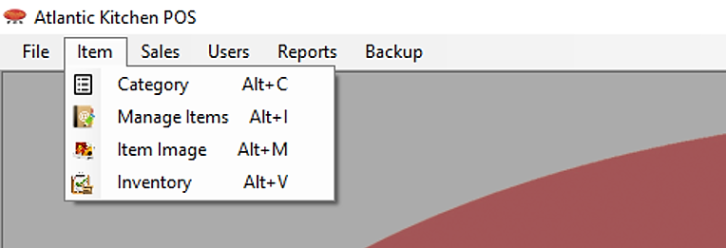**Item Menu**

1. Click **Item** menu.
2. Then, click **Category** or press **Alt + C**. Click **Manage** **Items** or press **Alt** **+ I**. Click **Item** **Image** or press **Alt** + M. Click **Inventory** of press **Alt + Y.**

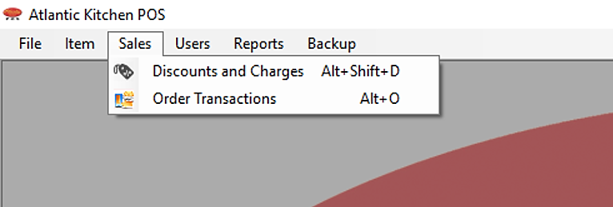

**Sales**

1. Click **Sales** menu.
2. Then, click **Discounts** and **Charges** or press **Alt + Shift + D** button on the list. Click **Order** **Transactions** or press **Alt + O.**

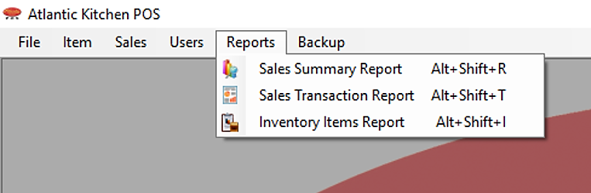**Reports**

1. Click **Reports** menu.
2. Then, click **Sales** **Summary** **Report** or press **Alt + Shift + R**. Click **Sales** **Transaction** **Report** or press **Alt + Shift + T**. Click **Inventory** **Items** **Report** or press **Alt + Shift + I.**

### **Category**

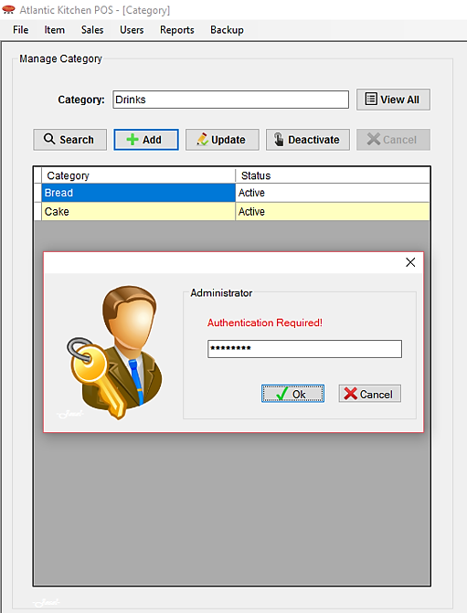

**To Add Category:**

1. Input **Category** name.
2. Then, click **Add** button.

**To Search Category:**

1. Input **Category** name.
2. Then, click **Search** button.

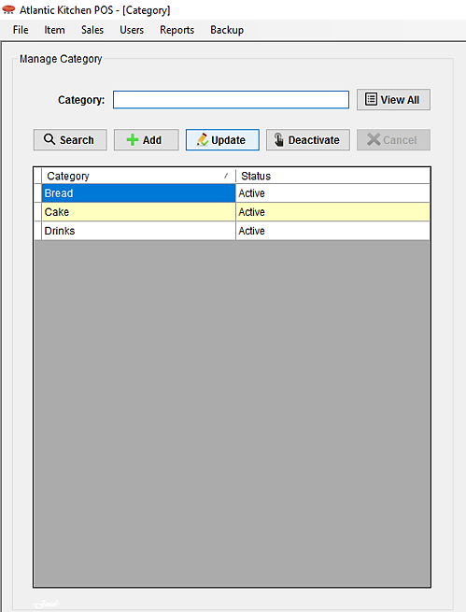

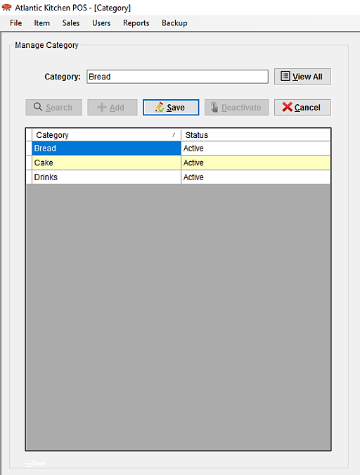**To Update Category:**

1. Select the **category** **name** in the list that you want to update.
2. Then, click **Update** button.
3. Then, after updating category name click **Save** button.

**To Deactivate / Activate:**

1. Select the **category** **name** in the list you want to deactivate / activate category.
2. Then, click **Deactivate** / **Activate** button.

**To View All Category:**

1. Click View All button.

### **Manage Items**

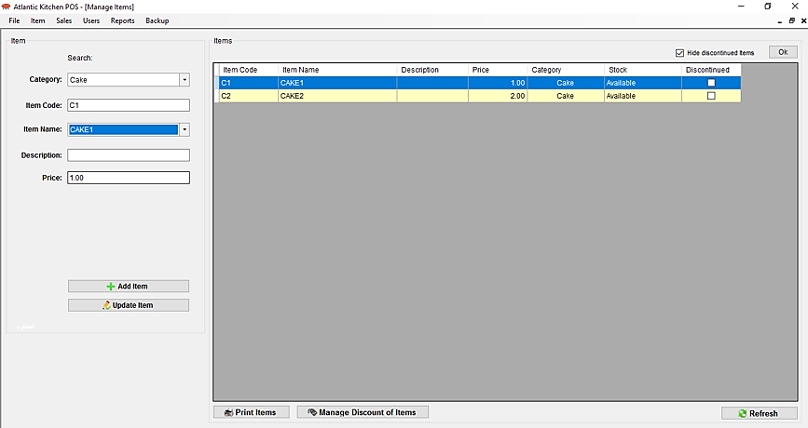

**To Search Item:**

1. Select **category** first.
2. Then, select **item** **name**.

**To Refresh Item List:**

1. Click **Refresh** button.

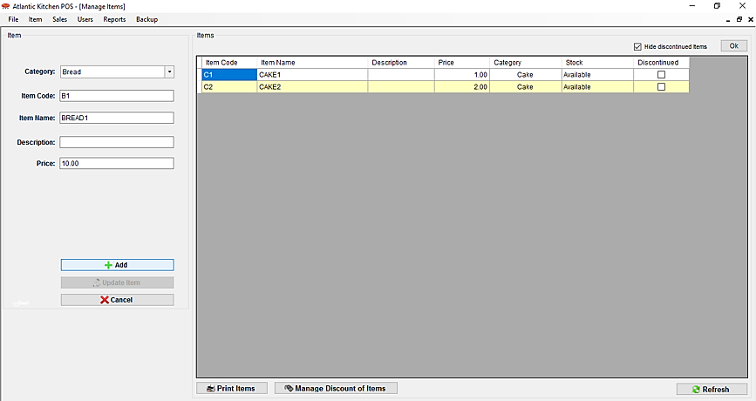

**To Add Item:**

1. Choose **category**.
2. Then, input **item** **code**, **item** **name**, **description** (optional) and **item** **price**.
3. Then, click **Add** button.

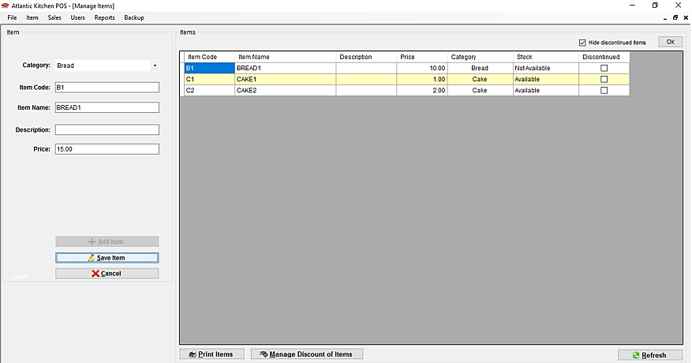

**To Update Item:**

1. Select **item** **name** that you want to update in the list.
2. Then, click **Update** button.
3. After updating, click **Save** button.

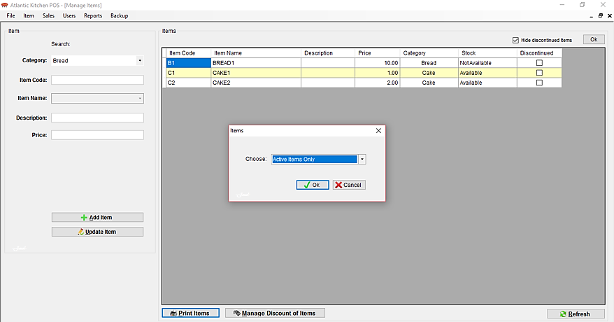

**To Print List of Items:**

1. Click **Print** **Items** button.
2. Then, choose from the list you want to print.
3. Then, click **Ok** button.
4. The **Item** **List** **Preview** will show.
5. Click **Print** **button** to print.

**Manage Discount of Items** (for grouped meals and items with different sizes in Senior and PWD discount)

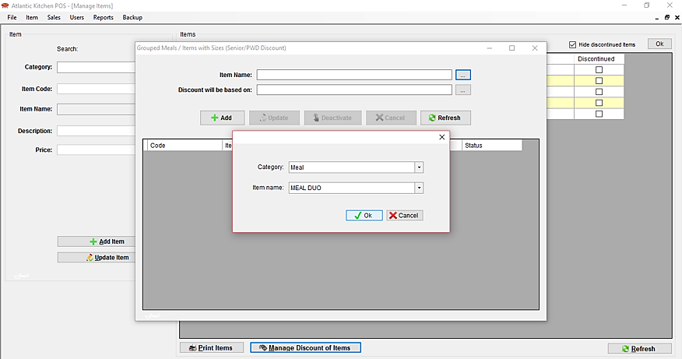

**To Add:**

1. Click the **Manage** **Discount** **of** **Items** button.
2. A windows form will appear. Click the **ellipsis** button corresponding to the item name to select the name of the item, likewise to the item where the discount will be based on.
3. Click **Add** button.

**To Update:**

1. 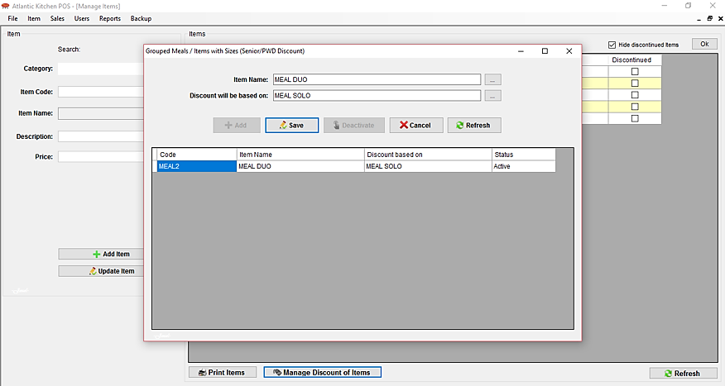Select the **item** **code** you want to update.
2. Then, click **Update** button.
3. After updating, click **Save** button.

**To Deactivate / Activate:**

1. Select the **item** **code** you want to deactivate / activate.
2. Then, click **Deactivate** / **Activate** button.

**To Refresh:**

1. Click **Refresh** button.

### **Item Image**

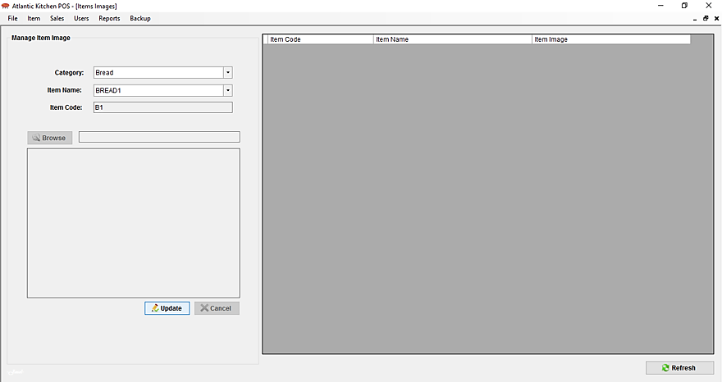

**To put Image for Items:**

1. Select **category** of the item first.
2. Then, select **item** **name**.
3. Then, click **Update** button.

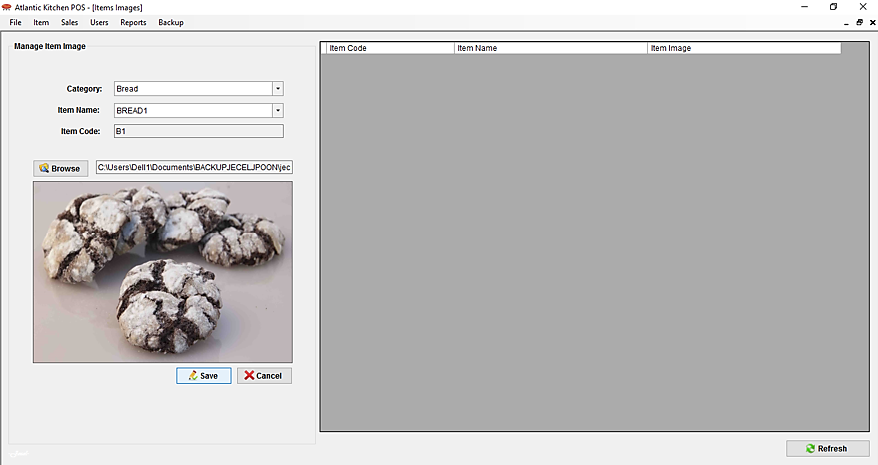

1. Then, click **Browse** button.
2. Then, browse the image. Click **Open**.
3. Then click **Save** button.

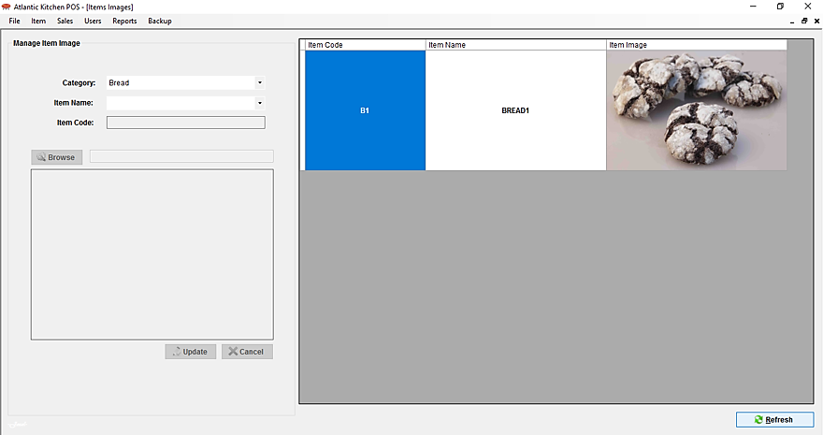

**To Refresh the List:**

1. Click the **Refresh** button

### **Inventory Items**

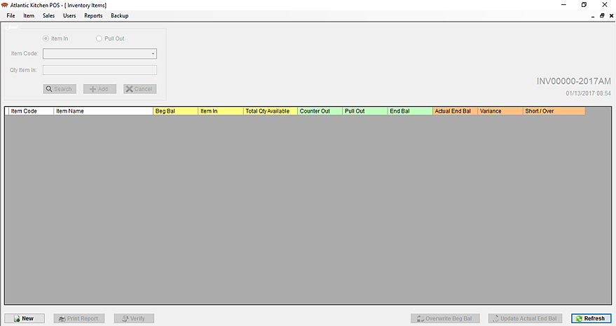

**To Create New Inventory:**

1. Click **New** button to create new inventory of items for the day.

**To Refresh Inventory:**

1. Click **Refresh** button.

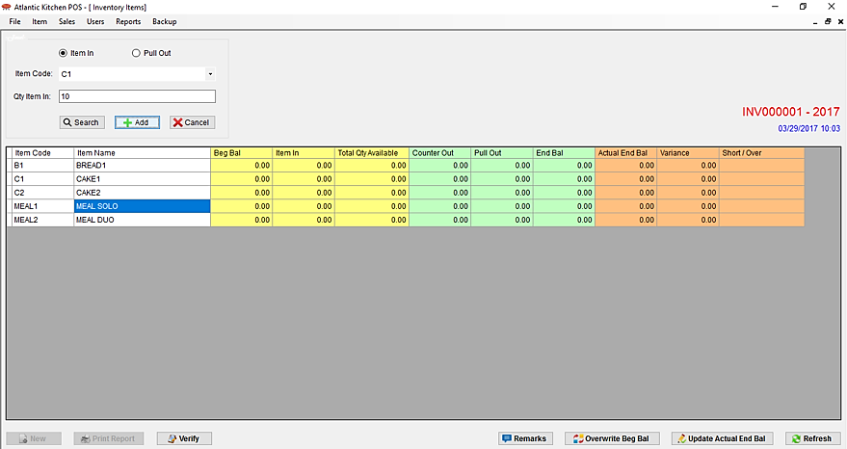

**To Add Item In:**

1. Choose **Item** in option first.
2. Select the **item** **code**.
3. Then, input **quantity** of item in.
4. Then, click **Add** button.

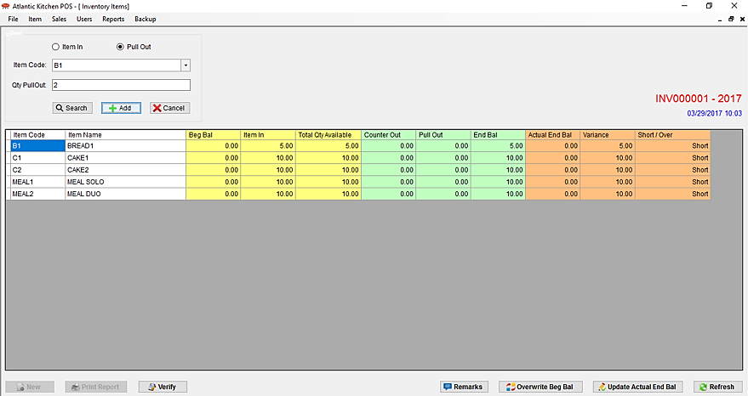

**To Add Item Pull Out:**

1. Choose **Pull** **Out** option first.
2. Select the **item** **code**.
3. Then, input **quantity** of item pull out.
4. Then, click **Add** button.

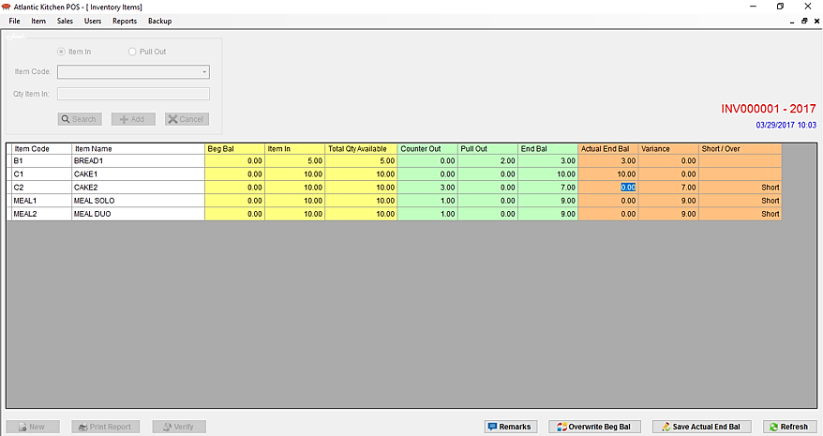**To Search Item in Inventory:**

1. Select item **code** first.
2. Then, click **Search** button.

**To Update Actual End Balance of Inventory:**

1. Click **Update** **Actual** **End** **Bal** button.
2. Then, modify the **actual** **end** **bal** column in the list.
3. Then, click **Save** **Actual** **End** **Bal** button.

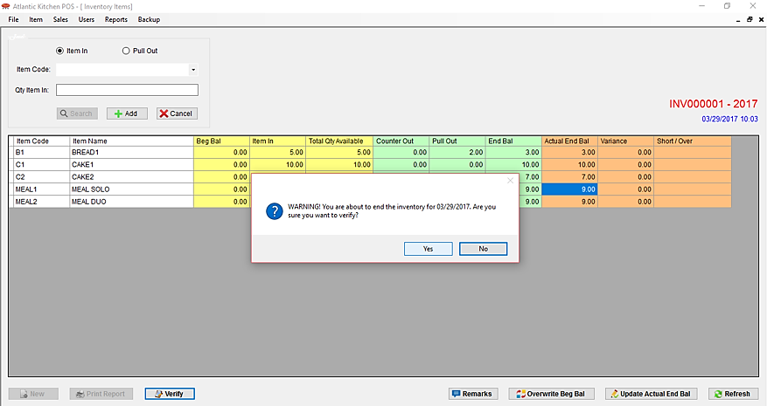

**To Verify the Inventory:**

(Verify to settle the Inventory of the day)

1. Click **Verify** button.
2. Then, a message will appear, click **Yes** button.

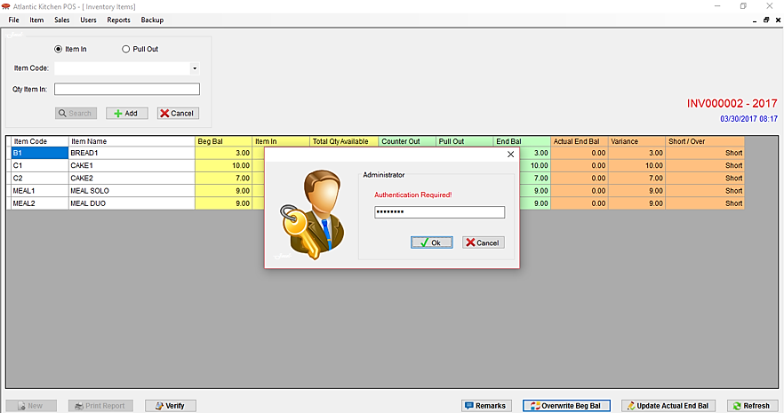

**To Overwrite Beginning Balance of Inventory:**

(Overwrite Beginning Balance if there’s revision in the previous Actual End Balance)

1. Click **Overwrite Beg Bal** button.
2. Then, input **administrator’s / manager’s password** to continue.
3. Then, modify the **beg bal** column of the item you want to overwrite in the list.
4. Then, click **Save Overwrite Beg** button.

### **Discounts and Charges**

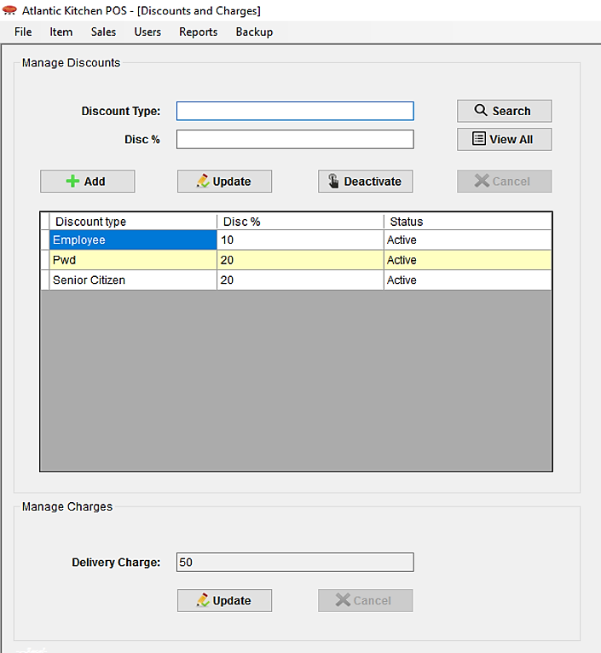

**To Add Discount Type:**

1. Input **Discount Type name** and the **amount** of discount in percent.
2. Then, click **Add** button.

**To Update Discount Type:**

1. Select the **discount** **type** in the list that you want to update.
2. Then, click **Update** button.
3. Modify the **discount** **type** or the **amount** of discount.
4. Then, click **Save** button.

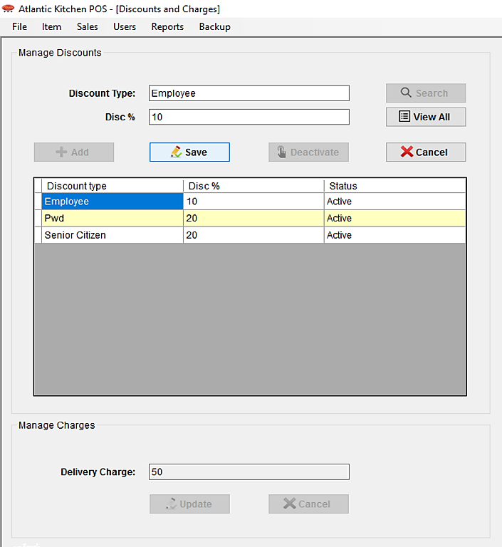

**To Deactivate / Activate Discount Type:**

1. Select the **discount type** in the list that you want to deactivate / activate.
2. Then, click **Deactivate** / **Activate** button.

**To Search Discount Type:**

1. Input **discount type**.
2. Then, click **Search** button.

**To View All Discount Type:**

1. Click **View All** button.

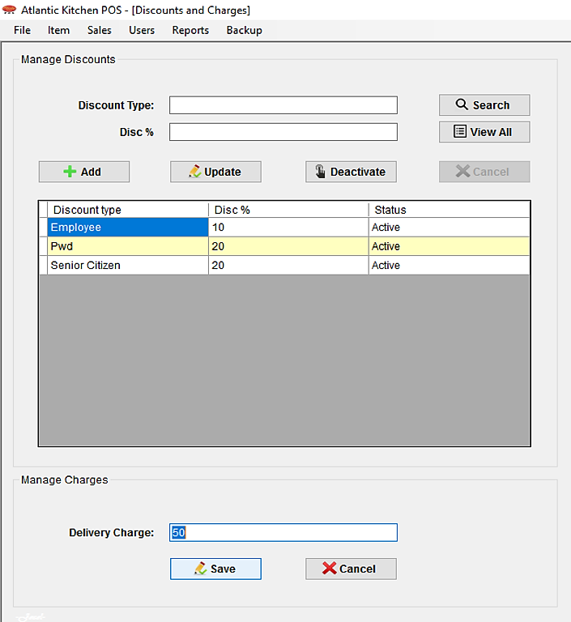

**To Update Delivery Charge:**

1. Click **Update** button.
2. Then, modify the **delivery** **charge**.
3. Then, click **Save** button.

### **Order Transaction**

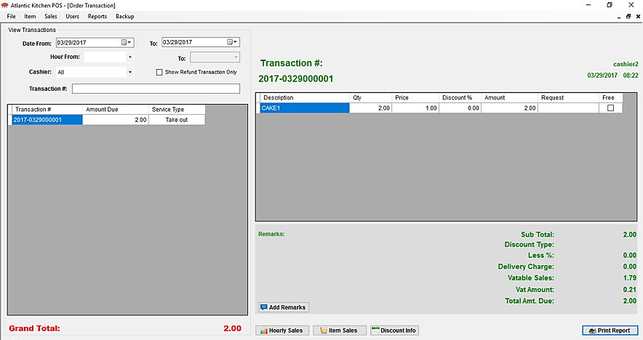**To View the Order Transactions**

1. Select **date(s)** of the transactions.
2. You can filter by selecting **hour range** and/or **cashier name.**
3. You can also see the refund transactions by checking the checkbox **Show** **Refund** **Transactions**.
4. Then, click the **transaction** **number** in the list to view the customer’s order list.

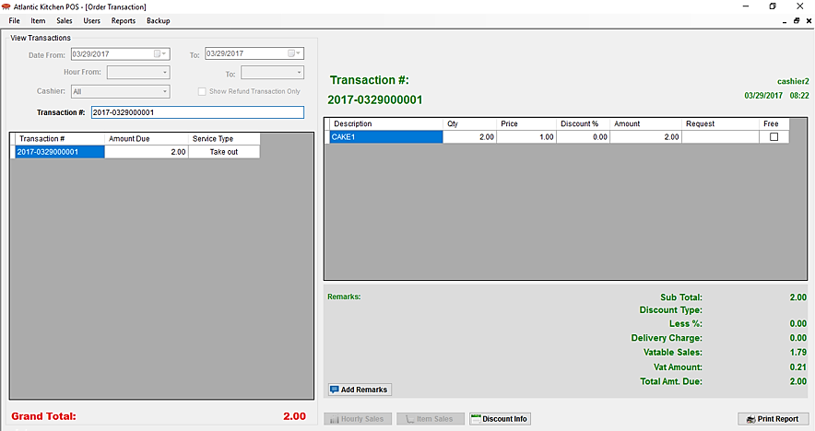

**To Search a specific Transaction**

1. Input the **transaction** **number** in the transaction # field.
2. Then, press **Enter**.
3. Click the **transaction** **number** in the list to view the customer’s order list.

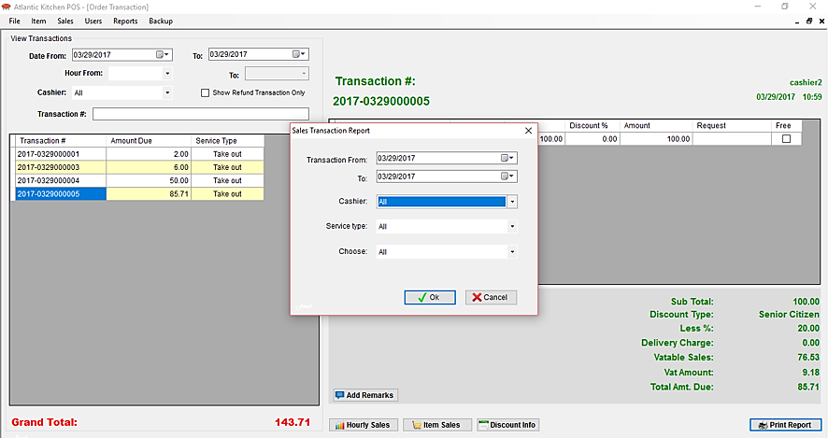**To Add Remarks in the transaction:**

1. Click **Add Remarks** button.
2. Then, input the **remarks**.
3. Then, click **Add** button.

**To Print the Sales Order Transaction Report:**

1. Click the **Print** button.

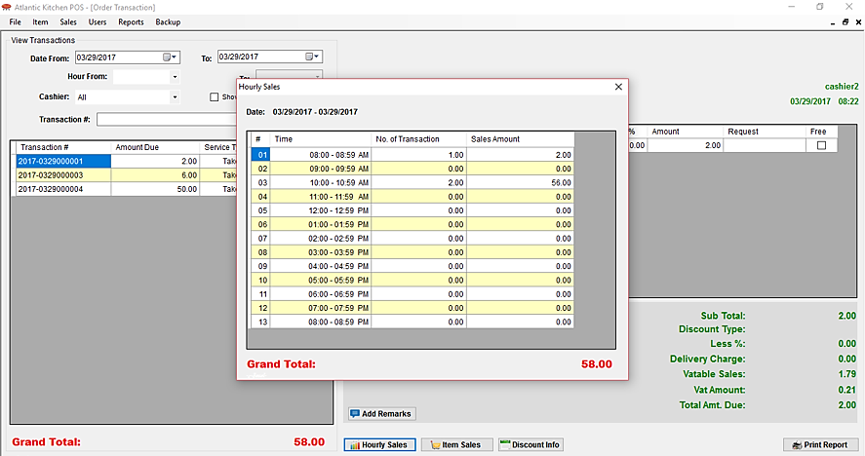

**To View the Sales per Hour:**

1. Select **date(s)** of the transactions.
2. You can filter by selecting **hour range** and/or **cashier name.**
3. Click the **Hourly Sales** button.

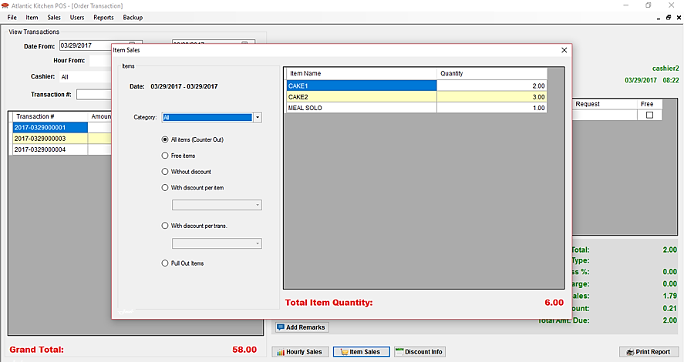

**To View the Item Sales:**

1. Select **date(s)** of the transactions.
2. You can filter by selecting **hour range** and/or **cashier name.**
3. Click the **Item Sales** button.
4. Then, choose from the option that you want to view.

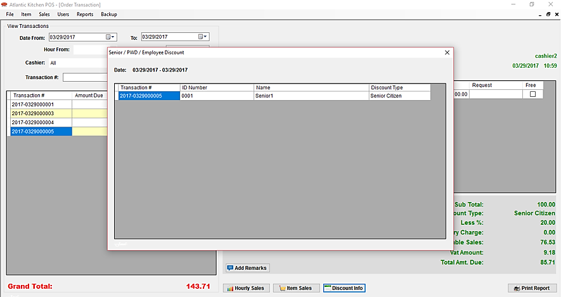

**To view the Discount Customer’s Information:**

1. Select **date(s)** of the transactions.
2. You can filter by selecting **hour range** and/or **cashier name**.
3. Then, click the **Discount Info** button.

### **Manage Users**

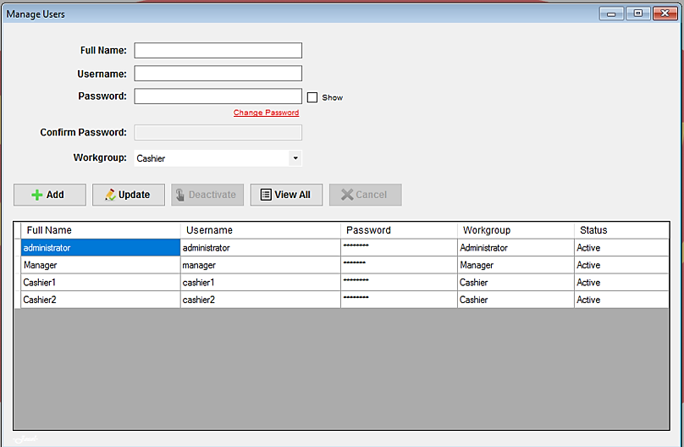

**To View All the Users:**

1. Click the **View All** button.

**To Deactivate / Activate the User Account:**

1. Select the **user account** in the list you want to deactivate / activate.
2. Then, click the **Deactivate** / **Activate** button.

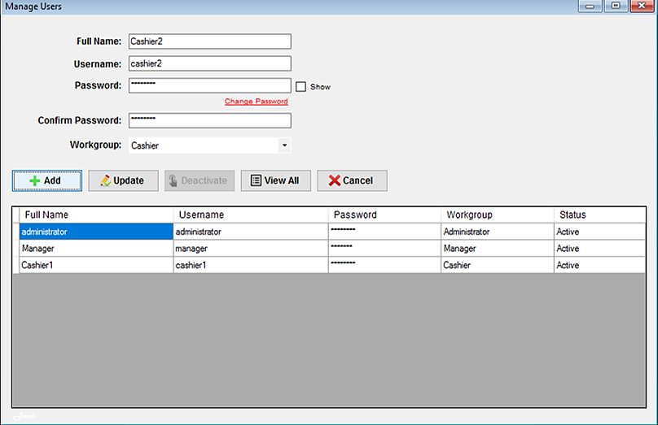

**To Add User Account:**

1. Input the **user account information.**
2. Re-type the **password** to confirm the password.
3. Then, select the **workgroup**.
4. Then, click the **Add** button.

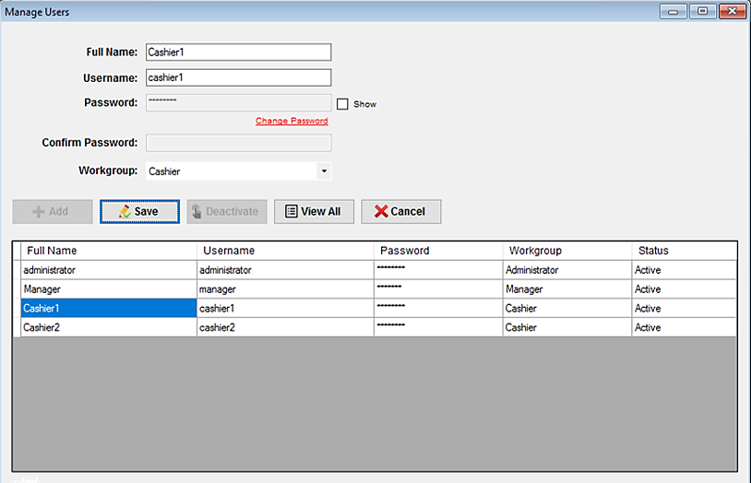

**To Update the User Account:**

1. Select the **user account** in the list that you want to update.
2. Then, click **Update** button.
3. Modify the **user account information.**
4. Then, click **Save** button.

### **Sales Summary Report**

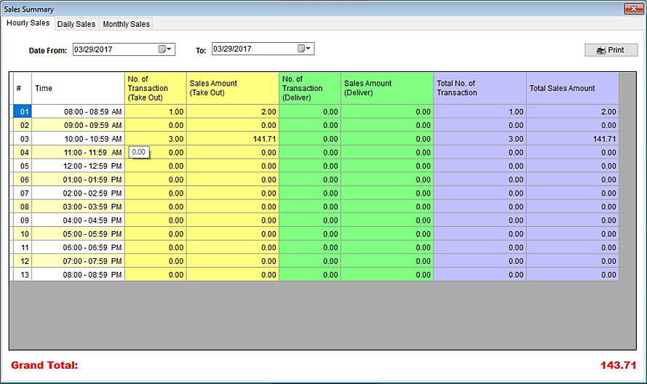

**To View the Hourly Sales Summary Report** with number of transactions and its corresponding service type.

1. Select the **Hourly** **Sales** tab.
2. 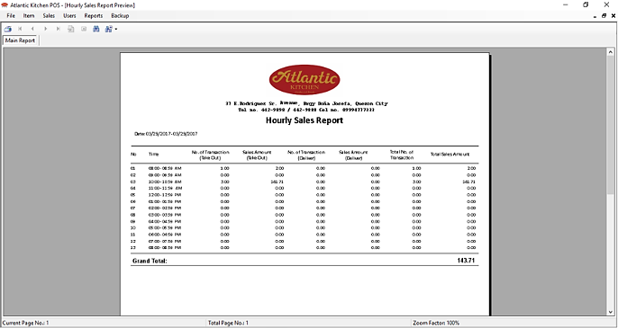Then, select the **dates** of the transactions you want to view.

**To Print the Hourly Sales Summary Report:**

1. Click the **Print** button.

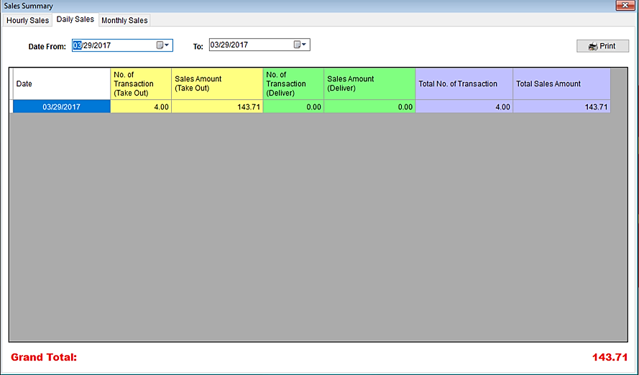

**To View the Daily Sales Summary Report** with number of transactions and its corresponding service type.

1. Select the **Daily** **Sales** tab.
2. 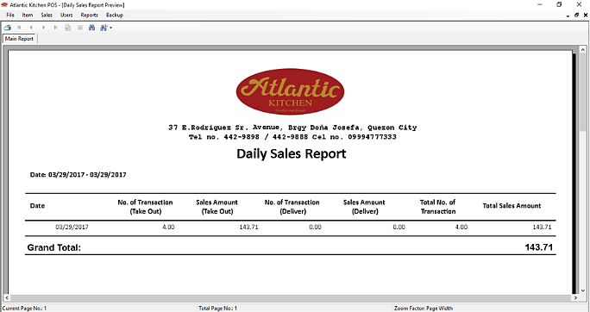Then, select the **dates** of the transactions you want to view.

**To Print the Hourly Sales Summary Report:**

1. Click the **Print** button. 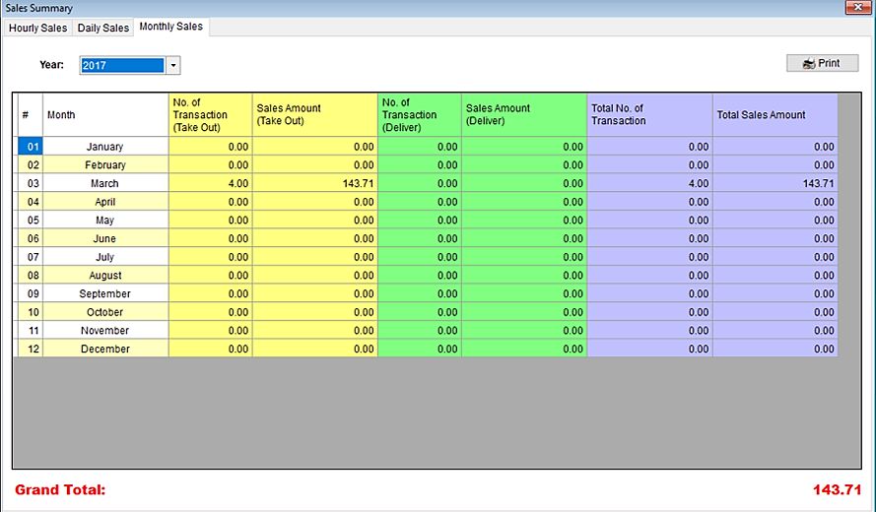**To View the Monthly Sales Summary Report** with number of transactions and its corresponding service type.
2. Select the **Monthly** **Sales** tab.
3. Then, select the **year** of the transactions you want to view.

**To Print the Monthly Sales Summary Report:**

1. Click the **Print** button.

### **Sales Transaction Report**

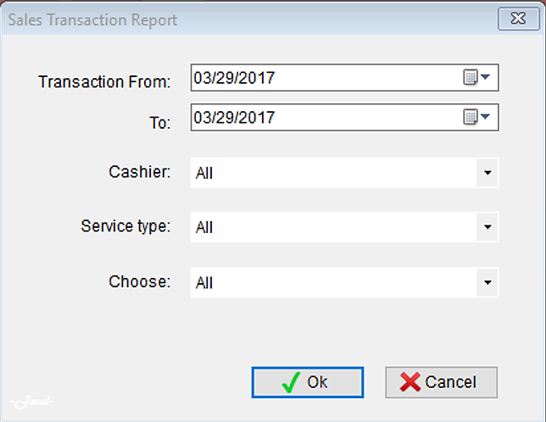

**To View the Sales Transaction Report:**

1. Select the **dates** of the transactions you want to view.
2. You can select from the **cashier**, **service** **type** and choose if **with** or **without** **discounts** transactions.
3. Then, click **Ok** button.
4. Then, the **Sales** **Transaction** **Report** will appear.

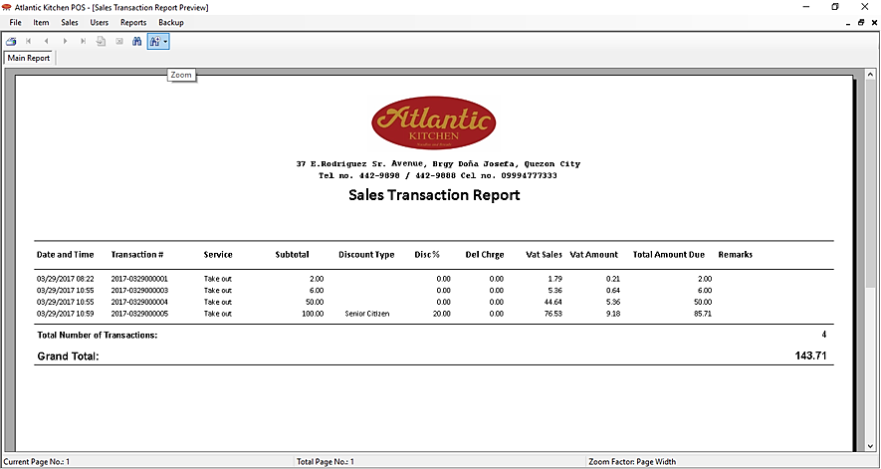

**To Print the Sales Transaction Report:**

1. Click the **Print** button.

### **Inventory Report**

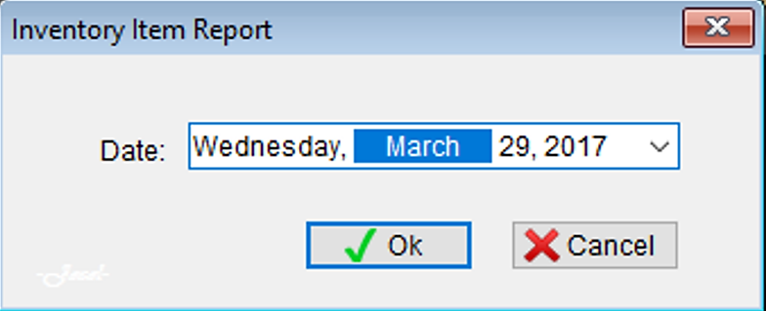

**To View the Inventory Report:**

1. Select the **date** of the inventory.
2. Then, click **Ok** button.

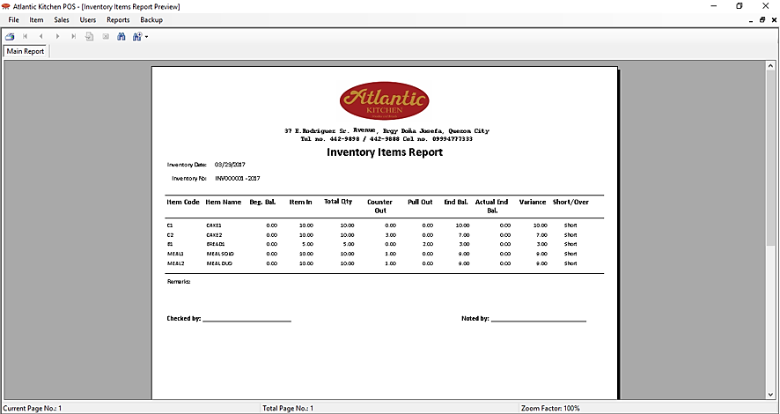

**To Print the Inventory Report:**

1. Click the **Print** button.

## **Cashier**

### **Login**

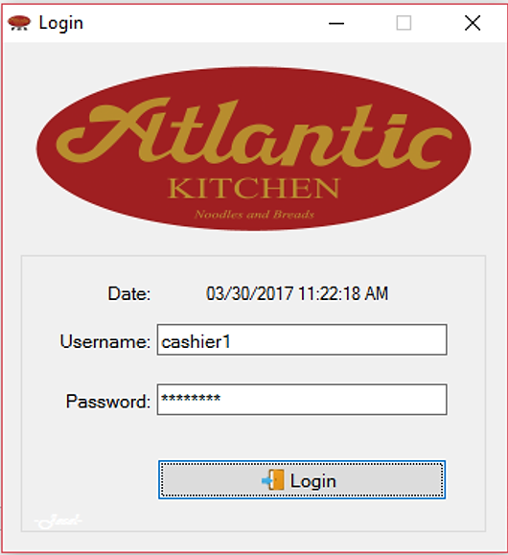

**To Login:**

1. Input **username** and **password**.
2. Then, click **Login** button. The main counter form will appear.

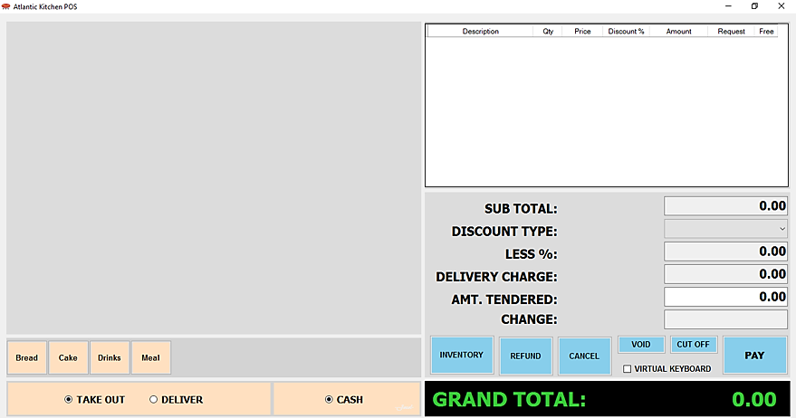

### Counter

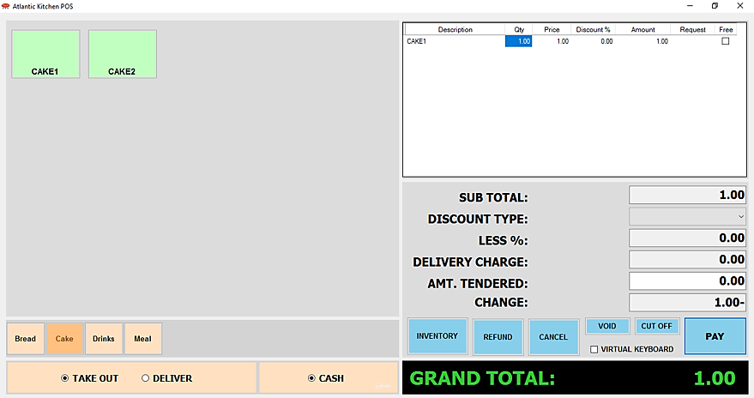

**To Add Transaction:**

1. Click the **category** of the item you want to enter.
2. Then, click the **name** of the item you want to enter.
3. Input **quantity** of the item.

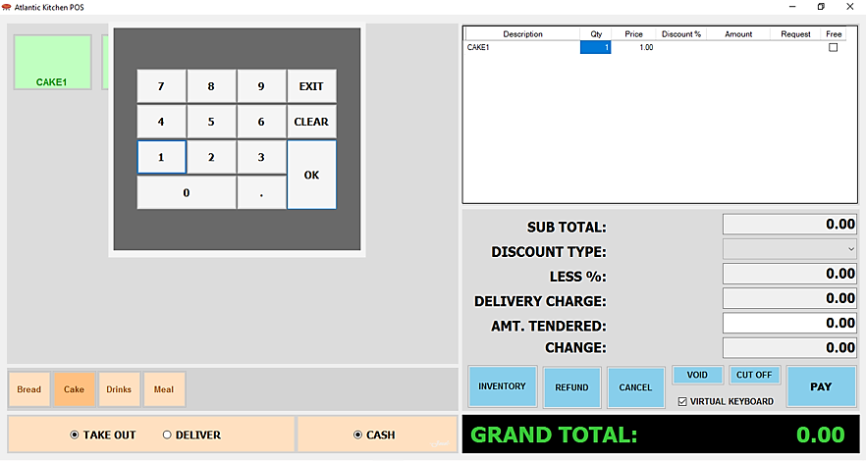

1. You can also input **discount** per item and if there’s any customer’s **request**.
2. You can also input the **quantity**, **discount per item, request and amount tendered** using the **virtual** **keyboard** just check the checkbox.
3. You can set the item(s) **free** by checking the checkbox in the free column.

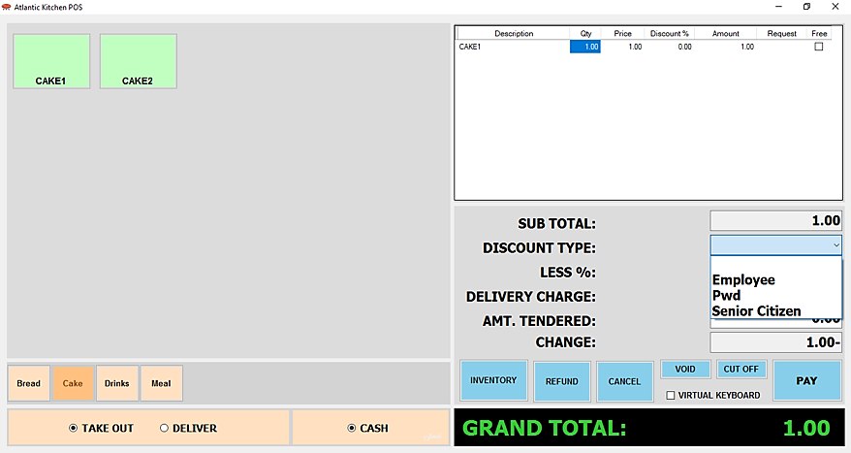

Select if **Take** **Out** or **Deliver**.

If there’s a **discount** for the transaction, select the discount type from the list.

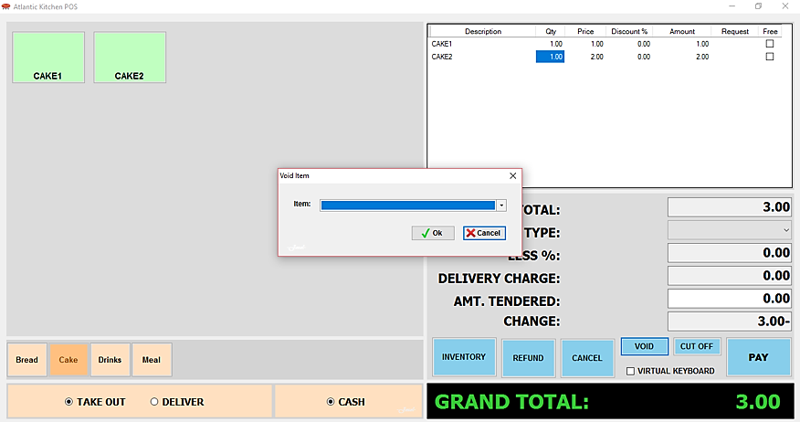

If you want to void item, click the **Void** button.

A windows form will appear.

Select the **name** of the item you want to void.

Then, click **Ok** button.

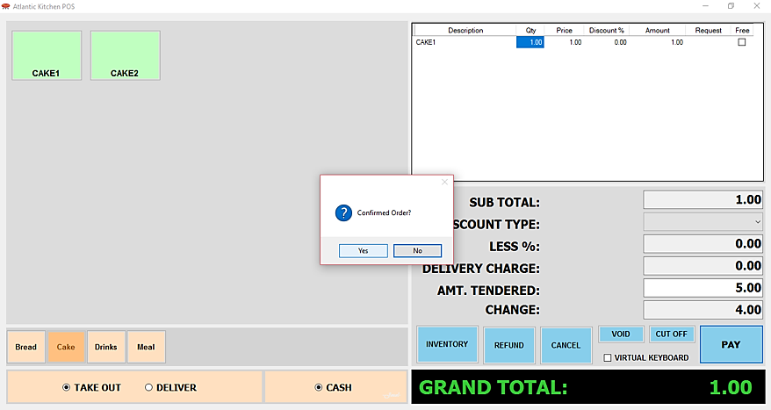

Input **amount tendered**.

Then, **confirm** the order of the customer.

Then, click the **Pay** button.

A message will appear, click **Ok** button.

Then, you can choose if you want to **print** receipt or not.

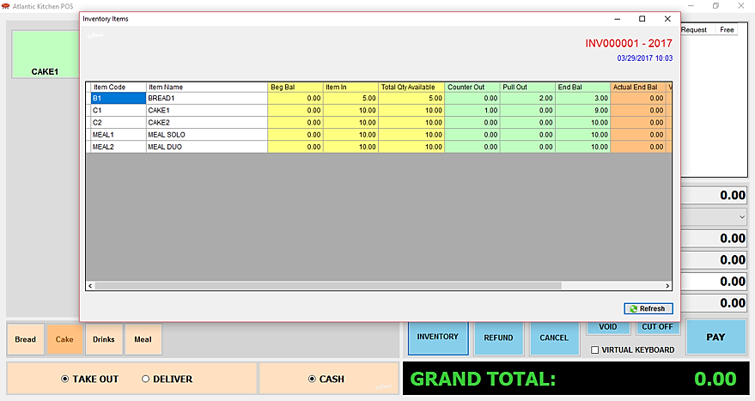

**To View the Inventory of Items:**

Click the **Inventory** button.

Then, click **Refresh** button to show the inventory list.

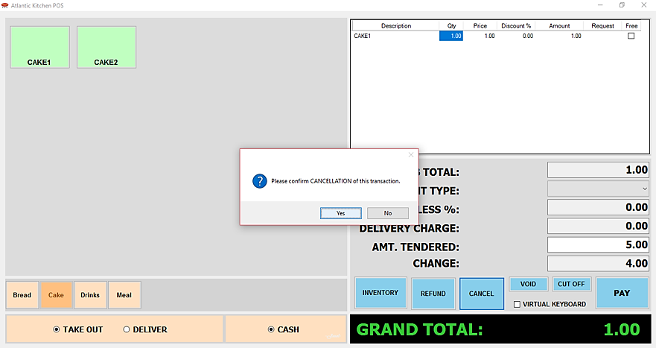

**To Cancel the Transaction:**

Click the **Cancel** button.

Then, a message will appear, click **Ok** button.

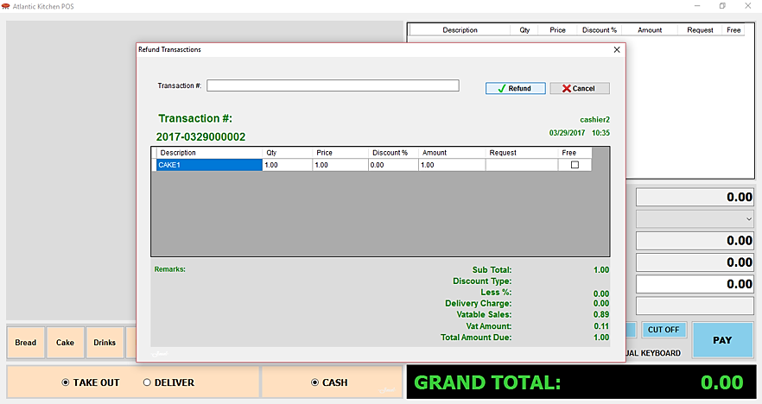

**To Refund Transaction:**

Input the **transaction** **number**.

Then, click **Ok** button.

The customer’s **order** **list** will show.

Then, click **Refund** button.

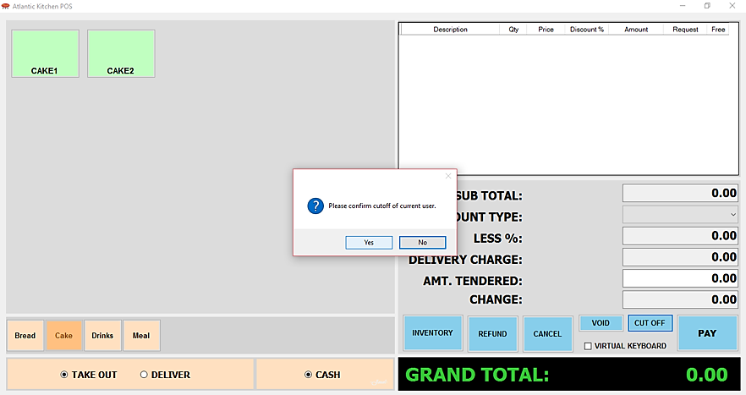

**To Logout:**

Click the **Cut** **Off** button.

A message will appear, click **Yes** button.